N15/4/COMSC/HP3/ENG/TZ0/XX



**Computer science**

**Higher level**

**Paper 3**

Wednesday 18 November 2015 (morning)

1 hour

**Instructions to candidates**

* Do not turn over this examination paper until instructed to do so.
* Answer all questions.
* The maximum mark for this examination paper is **[30 marks]**.

|  |  |  |
| --- | --- | --- |
| 2 pages | 8815 – 7013 |  |
| © International Baccalaureate Organization 2015 |  |

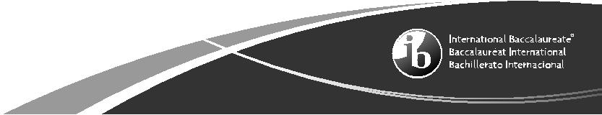

|  |  |  |  |  |
| --- | --- | --- | --- | --- |
|  |  | – 2 – | N15/4/COMSC/HP3/ENG/TZ0/XX | |
| Answer **all** questions. | | |  |  |
| **1.** | (a) | Define the term *WPA*. |  | [2] |
|  | (b) | Outline the function of the Sim Application Toolkit (STK) used in the M-PESA system. | | [2] |

1. (a) With the use of examples, outline the difference between push and pull technologies

used in SMS banking. [4]

1. A mobile phone with a specialized app is able to replace a bank card when a person gets money from an ATM. Some of these phones make use of QR codes.

Explain how these requests can be made using QR code technology. [4]

1. When a customer connects online to their bank’s website a precise series of steps are followed, involving the SSL protocol, in order to establish a secure connection.

Describe the steps that this procedure would follow. [6]

1. Fraud continues to be a major issue in the banking industry. Advances in technology have led to the development of multi-factor authentication, including the use of biometrics. *TransEuropa*, however, has not yet made the decision to introduce biometric technology.

Discuss whether the introduction of biometrics for the authentication of mobile users would

|  |  |
| --- | --- |
| be both an acceptable and successful way to reduce losses due to fraud. You should include |  |
| an evaluation of advances in technology and other methods of authentication, including those |  |
| used by *TransEuropa* in the case study. | [12] |